# Creating Visuals

1. Creating a **Pie Chart 🡪 1 Dimension and 1 Measure**

Click on the Pie Chart. **Put Pattern in Legend and Qty in Values**

The Pie Chart **by default** shows the **percentage contribution** of each Pattern in the tool tip when mouse is hovered.

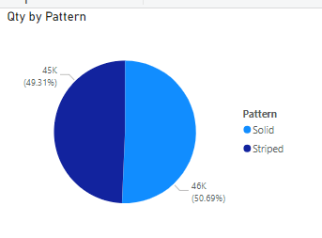

1. Creating a **Pie Chart 🡪 🡪 2 Dimensions and 1 Measure**

Click on the Pie Chart. **Put Pattern in Legend , Qty in Values And Neck Style in Details**

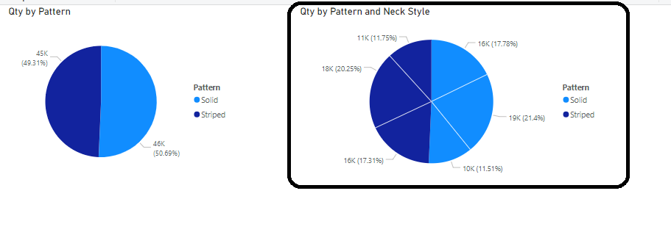

1. Creating a **Donut Chart**

A doughnut chart is similar to a pie chart in that it shows the relationship of parts to a whole.

The only difference is that the **center is blank and allows space for a label or icon.**

**Put size in Legend and Cost in Values.**

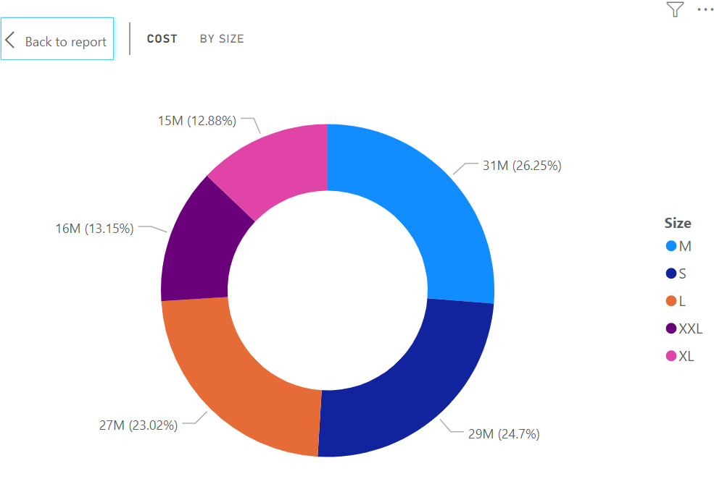

Doughnut charts & Pie charts are best used to compare a particular section to the whole, rather than comparing individual sections with each other.

1. **Clustered Column Chart And Clustered Bar Chart .** *(1st row, 4th Column)*
   1. **Put Sleeve Length in the Axis & Qty in the Values.**
   2. **Put Neck Style in the Legend.** We get the bifurcation once we put any field in the Legend.

Neck styles have come as a cluster for each Sleeve Length

Swap within Legend and Axis & see the changed effect!!! Now Colors have come as a cluster for each Sleeve Length.

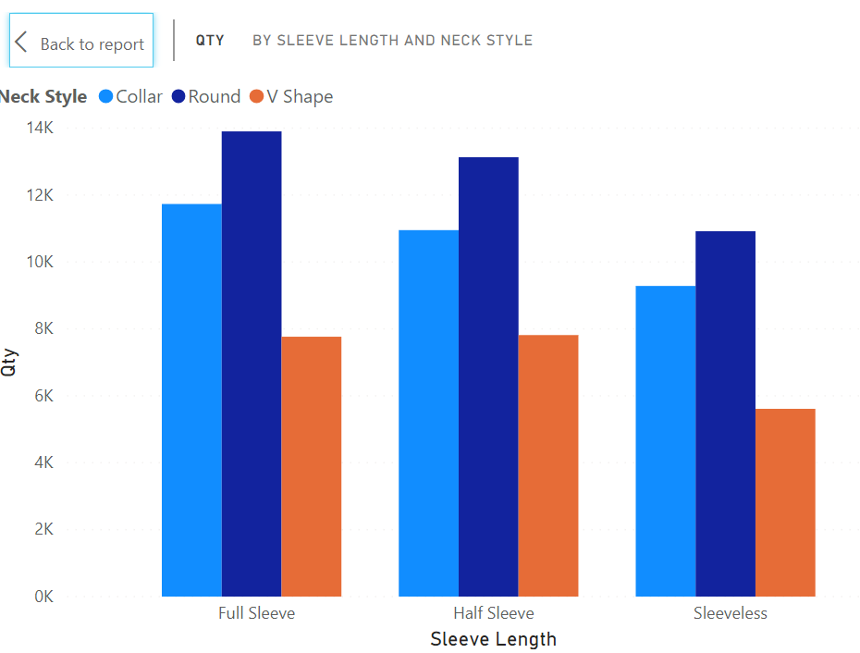

**Clustered Column Chart is suitable when we have 2 inputs i.e. Dimensions and 1 output i.e. Measure.**

**It can be also Clustered Bar Chart**

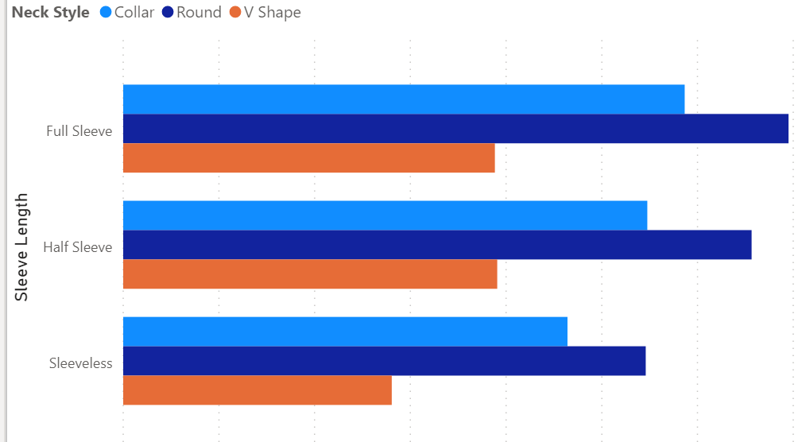

**\*\*\*\*\*\*\*\*\*\*\*\*\*Wrong Demo of Clustered Column Chart\*\*\*\*\*\*\*\*\*\*\*\*\***

Create one more **Clustered Column Chart**. Now we are going to have one input and two outputs. **Put Neck Style in Axis and in Values put Qty and Cost.** But this is NOT that effective as the Qty values are so small that we can make out. **So, this was wrong type of chart**.

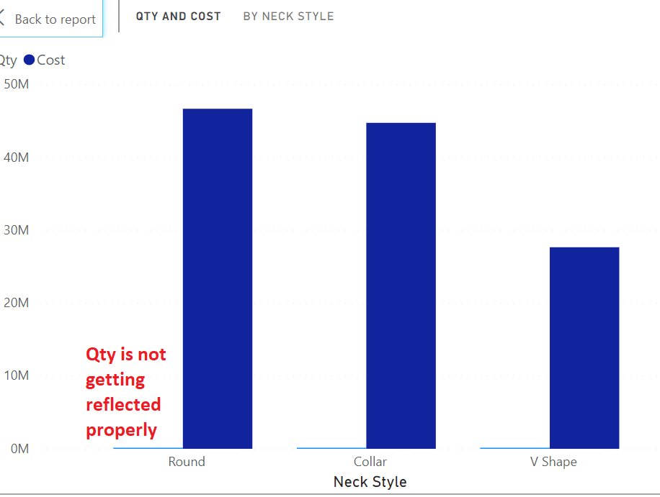

1. Now to solve the above problem create a new chart **Line and Stacked Column Chart**. *(2nd row, 4th Column)*

**Put Neck Style in Shared Axis, Qty in Column Values and Cost in Line Values.**

It makes sense now. So, for one input and two outputs the chart more effective is **Line and Stacked Column Chart!!!**

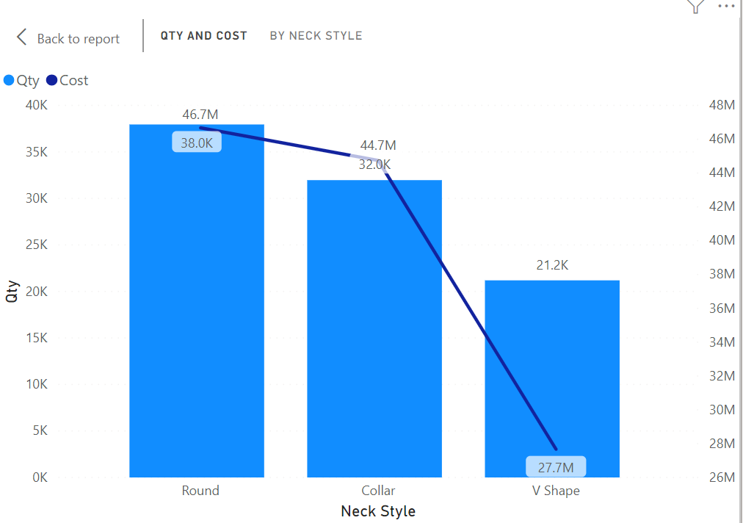

Note 🡪To show the values **Data Labels** are made on. By Default, they are off.

**Line and Stacked Column Chart is suitable when we have 1 input i.e. Dimension and 2 outputs i.e. Measures.**

1. Now we will create a **Funnel chart**.

**Put Size into Group and Qty into Values**.

The horizontal bars may or may not be sorted. So, click on the 3 dots and then sort by Qty Descending.

Now the most important different information that it is giving us is that Medium TShirts are sold maximum and XL are minimum, and they are 48.9% off the total sales of Medium TShirt. It is the 48.9% of the highest values, i.e. Medium. So, if 100 TShirts of Medium were sold then 48.9% will be sold of XL!

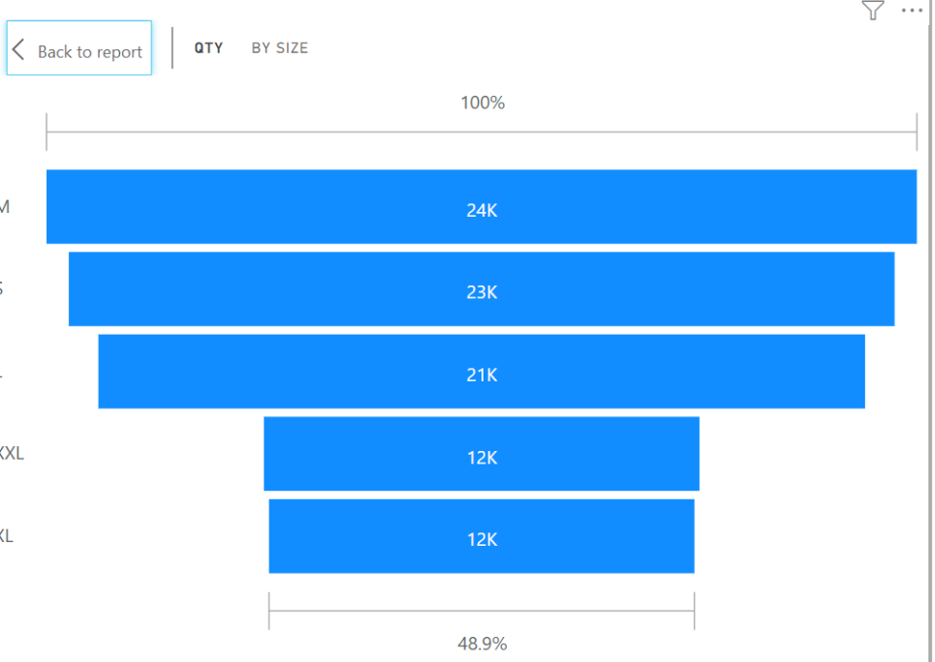

**Funnel Chart is suitable when we want to show the percentage contribution of each value with its previous and with the first.**

1. Now let’s create a **Line Chart**.

**Put Order Date into Axis & Qty into Values.**

**Line Chart is always good for Time Dimension.**

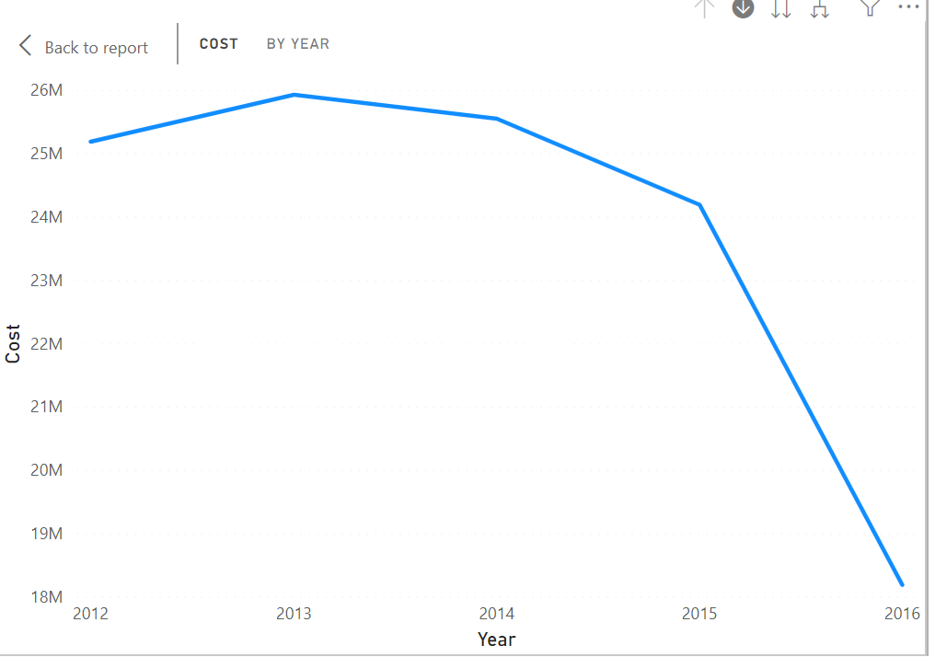

To zoom any chart, we have an option within the chart known as **Focus Mode**. So, click on that option of this Line chart. After that click on the double down arrow icon from the RHS top when in Focus mode. Year wise gets broken into Quarter wise. Again, click on that double arrow. Now it shows Month wise. Again, click on the double arrow. Now it is day wise. By up arrow move back up to Year wise back!

**That means for date values a hierarchy gets created implicitly and it seen good through Line Chart.**

1. Now we will create a **Matrix**.

In Power BI a Pivot Table is called as **Matrix**.

**Put Size in Rows, Pattern in Columns and Qty in Values.**

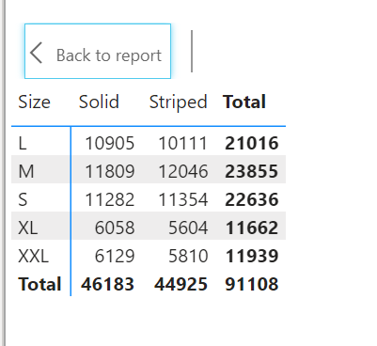

**Now put Sleeve Length in the Rows section just below the Size. Drill down will get enabled!!!**

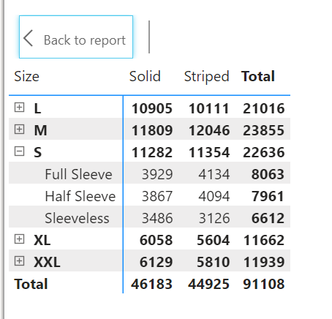

**Show Values as Percent of Column Total**

For that first click on the drop down of Qty from **Values** section.

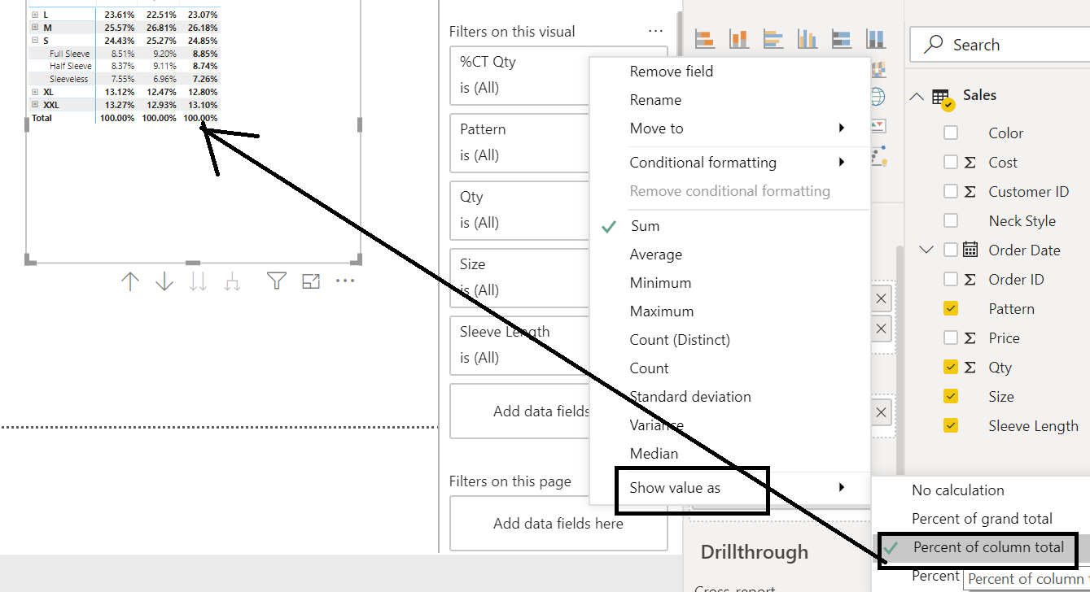

1. Waterfall Chart

Consider the data from **Targets** Sheet

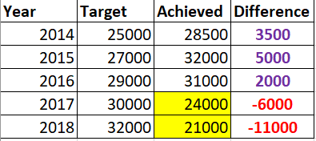

Place Waterfall Chart

**Put Year in the Category.**

**Put Difference in the Values.**

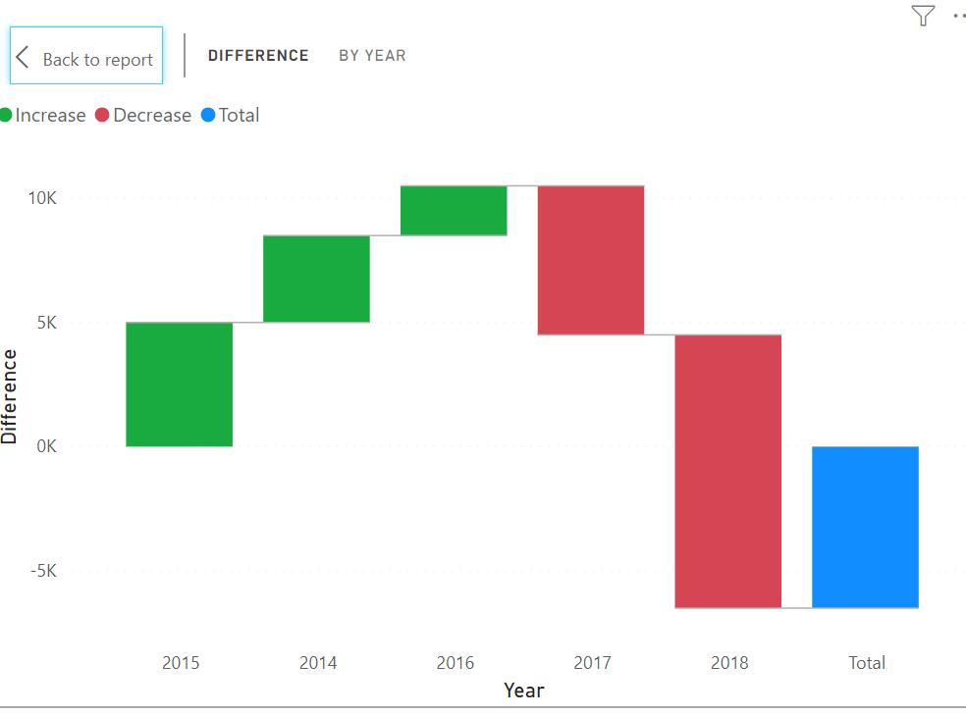

So, what do we understand by this chart??

Ans 🡪 In 2015 year you have over achieved by 5000

In 2016 year also you have over achieved by 3500

In third year also, you over achieved

But in 4th year you have under achieved by 6000

In 5th year you have drastically underachieved to 11000 less.

So, the total of Difference is -6500

**It means that Waterfall chart is great when you are doing Periodic Analysis. When there is Difference between Targets and actual values. Something like Year wise, month wise.**